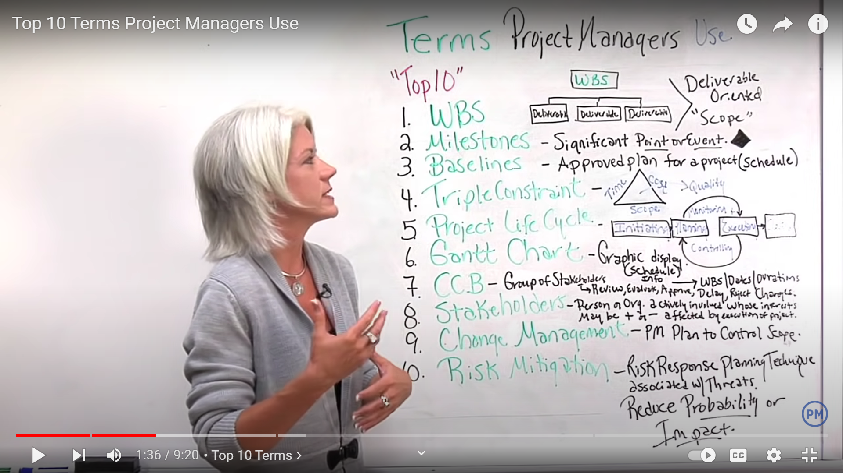

1. WBS : Work Break-Down Structure
2. 7. CCB : Change Control Board

